**User Manual**

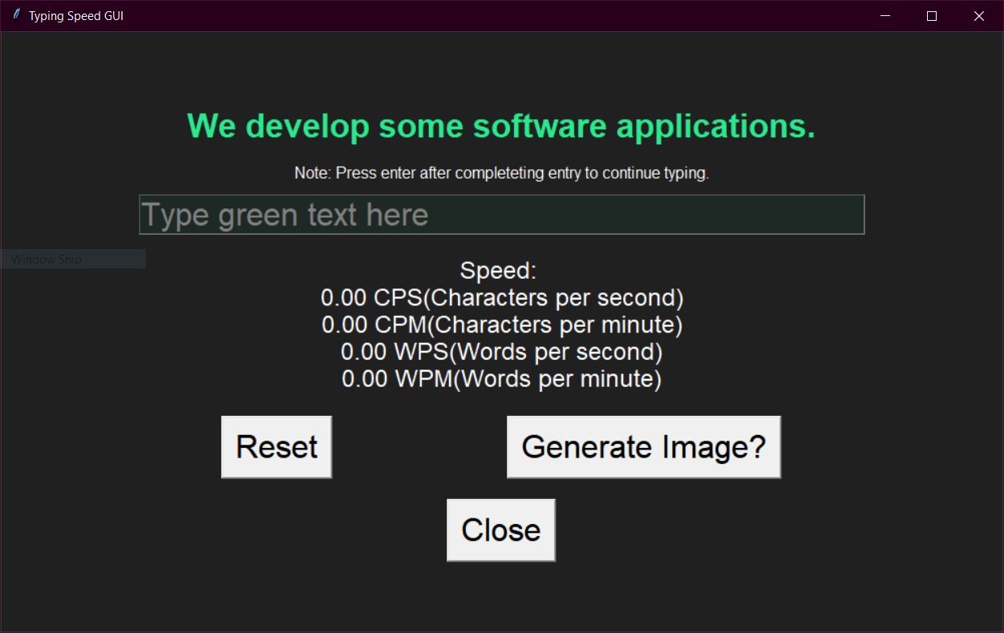

This is the starting image and in order to start typing you must click in the text box and type the green text two lines above it.

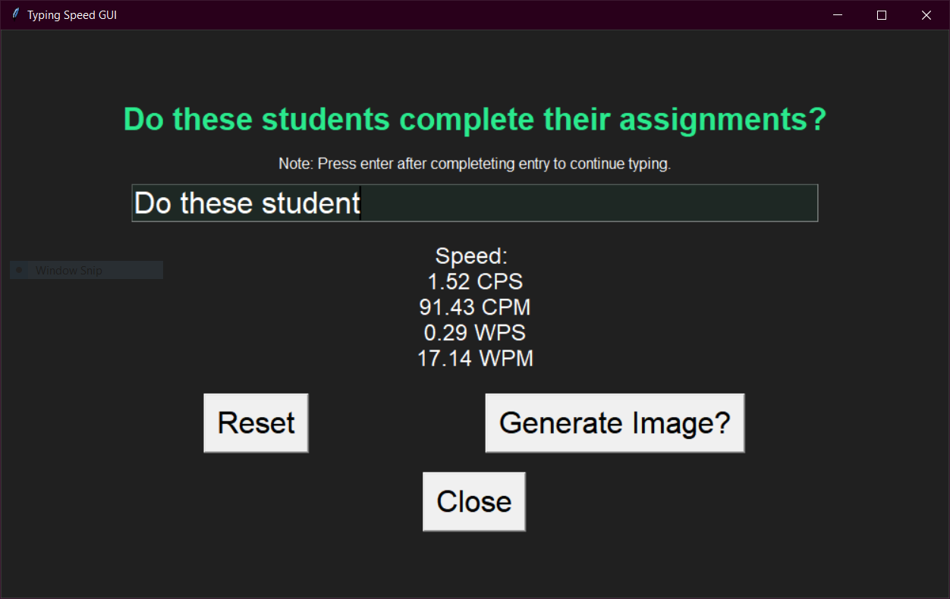

This is what your window if you are typing it in correctly. You can see your characters per second, characters per minute, words per second, and words per minute being displayed live.

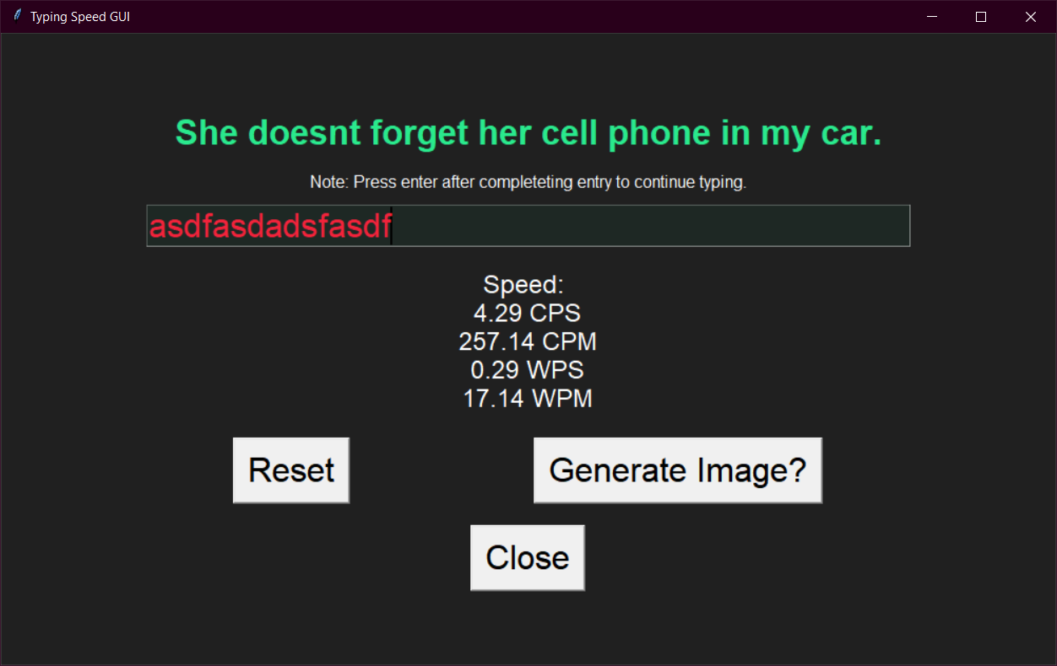

If you type in the wrong text, it will be displayed in red. This means that you have to go back and correct before your typing test suffers.

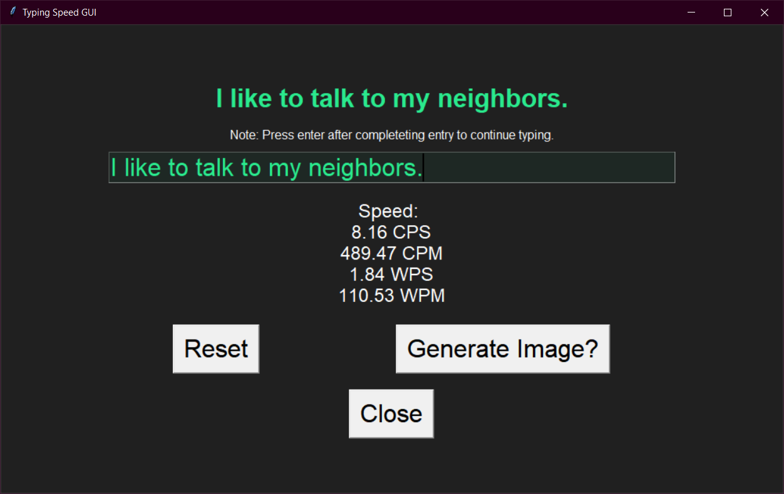

If you type it all in correctly, your entry will turn green, and your speed will stop updating showing your score. You can press enter on your keyboard to continue typing with a new phrase.

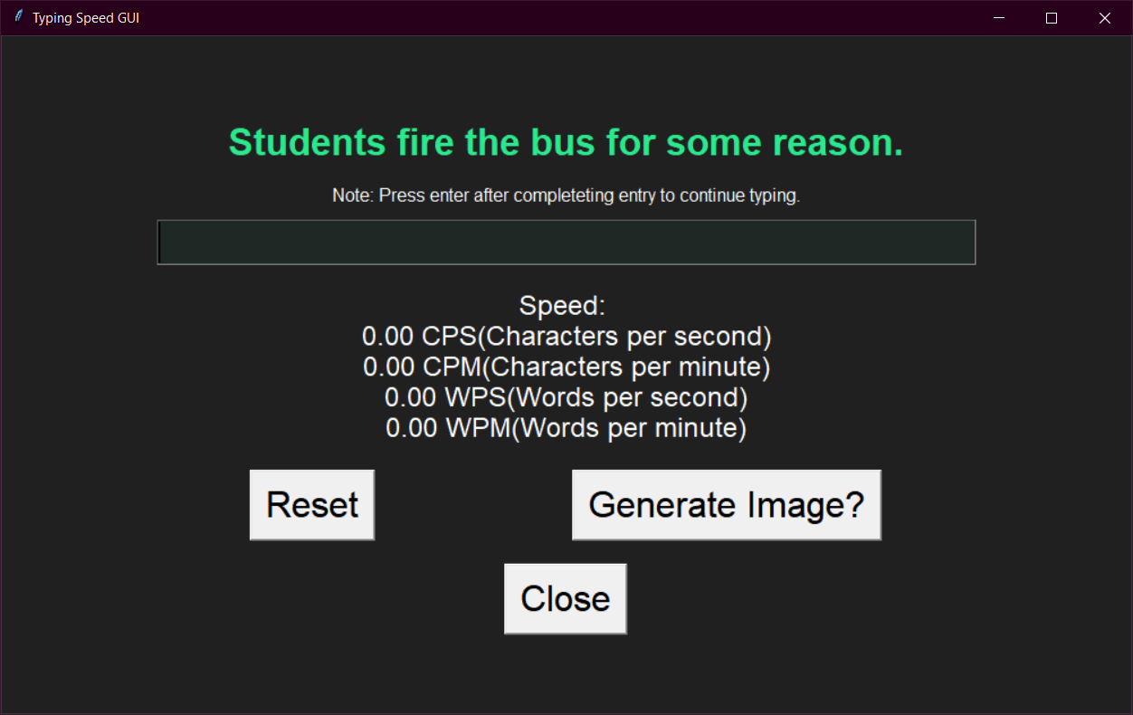

If you hit the Reset button, it will reset all of your progress and give you new sample text.



If you hit the Generate Image? Button it will load a random image in a new tab.

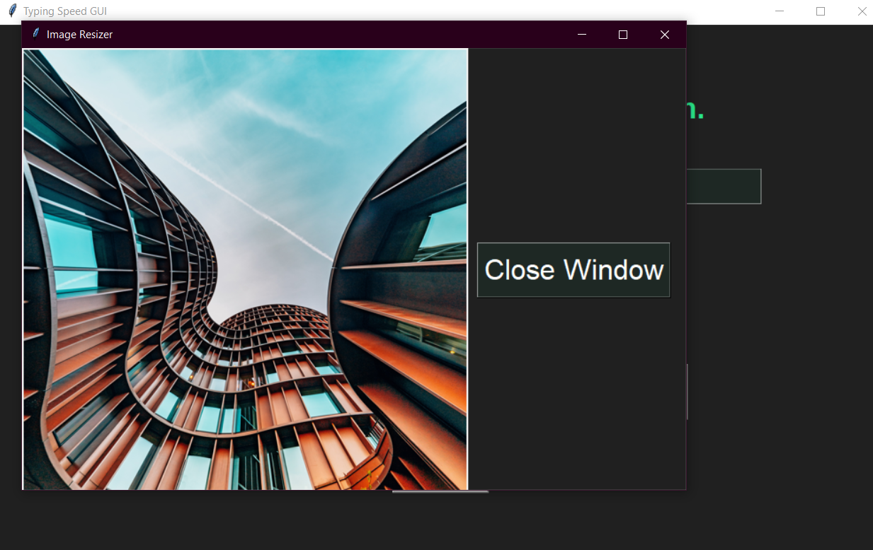

This is an example of what the opened image in a new tab will look like. You can close the window and generate a new image again if you would like.

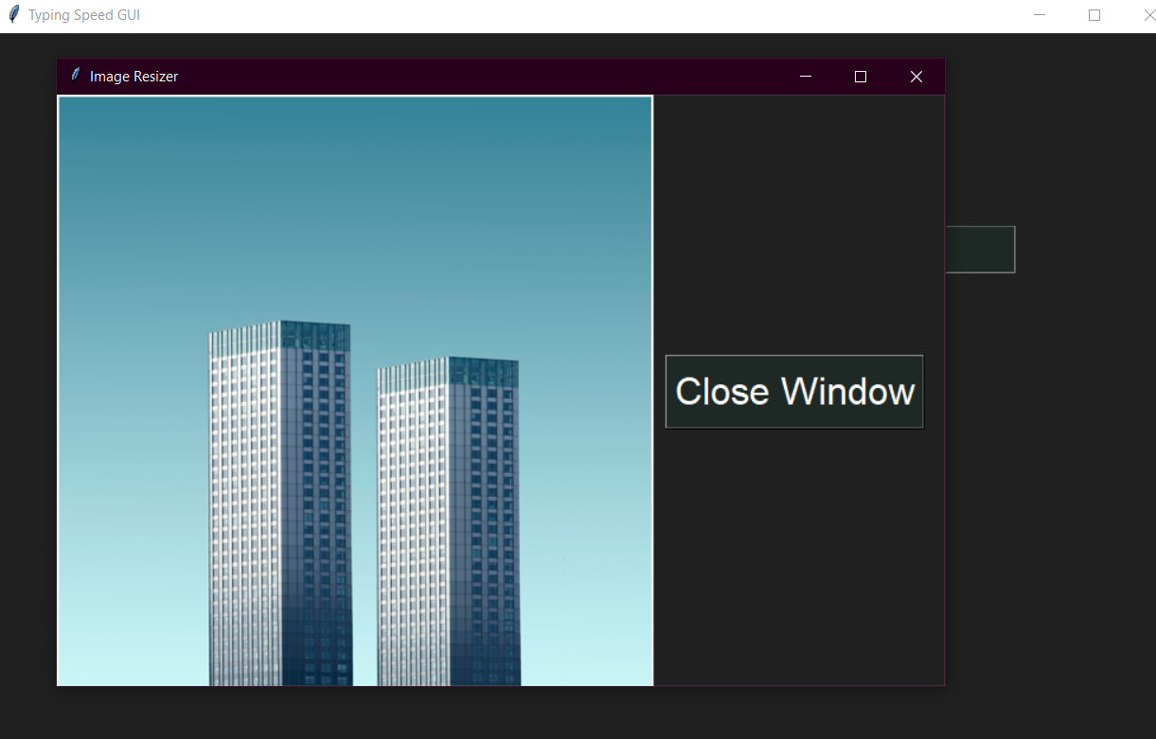

This is an example of another image.



If you hit the close button, it will exit the program entirely.

This concludes the user manual.

Any questions or bugs? Email me:

tmmcmasters@gmail.com